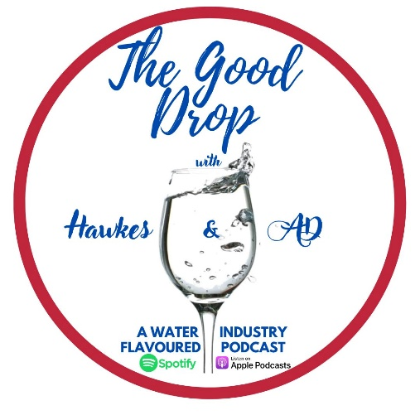
The Good Drop with Hawkes & AD – Episode Theme Suggestion
Name:
Position:
Contact Details:

Episode Theme Suggestion
- Please tell us in a few words, what theme would you like us to focus on and why?

- Are there any interviewee’s that we should contact in relation to this theme? Are you able to assist us by getting in contact with them?

- Do you have any feedback on our previous episodes where we have touched on the proposed theme? Can you provide any comments?

